**Task Day 8**

1. Sum of a&b is greater than c&d

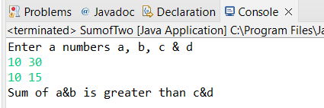

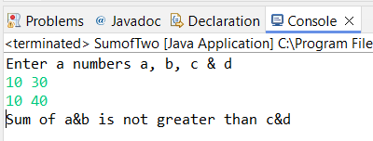

1. Even or Odd

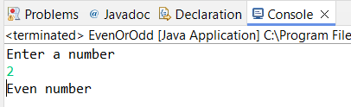

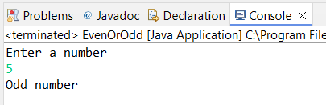

1. Print A-Z

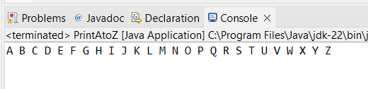

1. Swapping 2 numbers

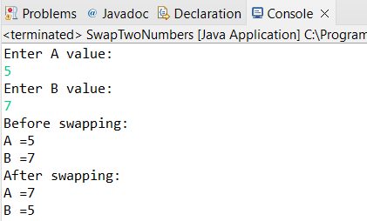

1. Prime or not

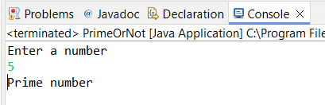

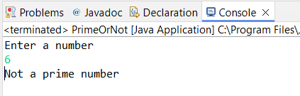

1. Factorial of a number

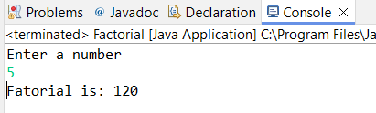

1. Length of given string

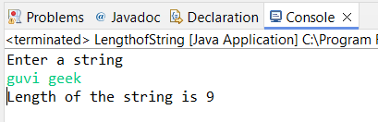

1. Print “Welcome to guvi” 10 times

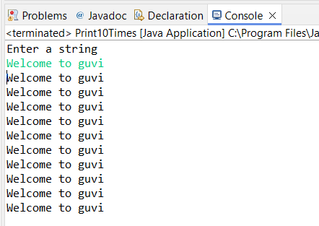

1. Senior citizen or not

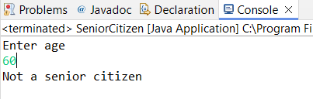

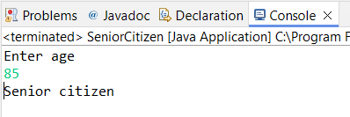

1. Count number of digits in an integer

